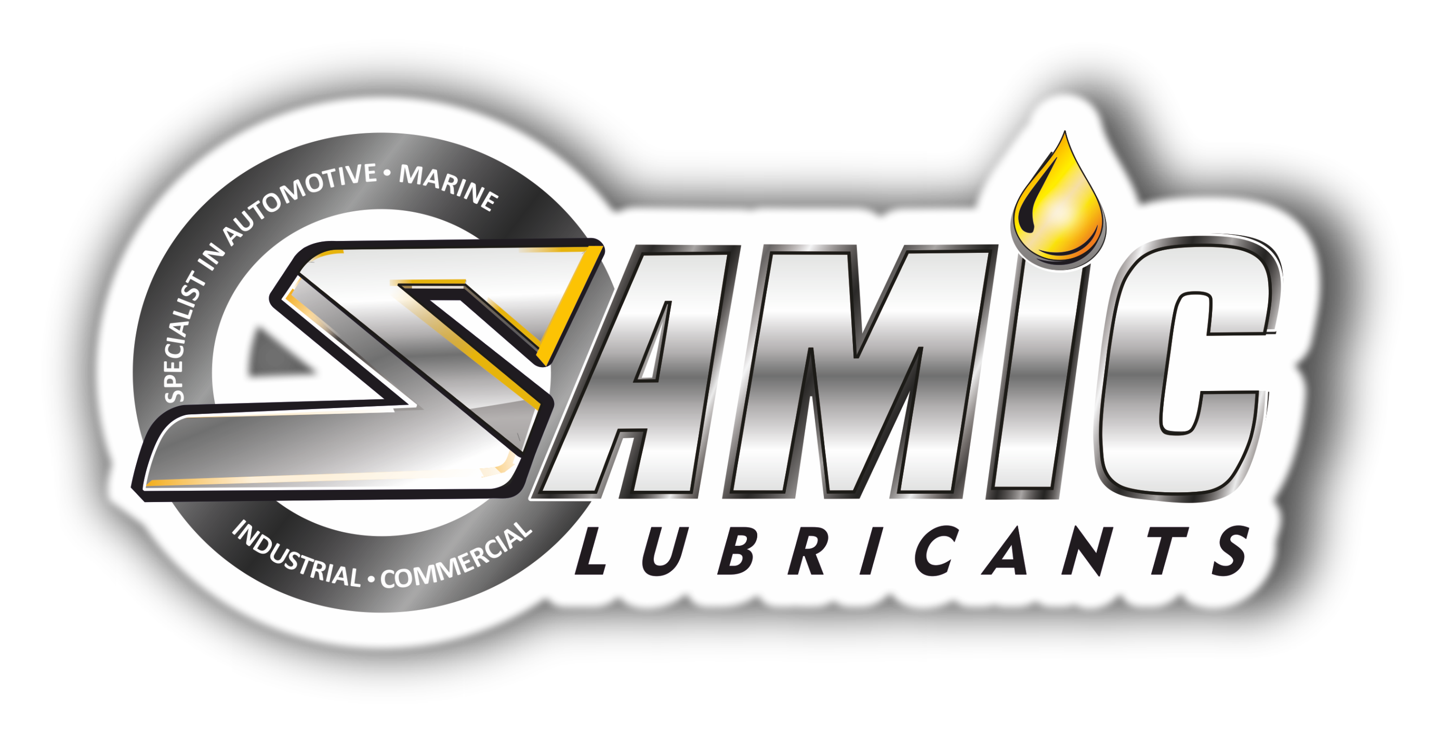

Samic Auto Trans ATF Type A
High performance Automatic Transmission Oil

Product Data Sheet
Product Description

Samic Auto Trans ATF Type A is a high performance automatic transmission oil, formulated with high quality base stocks, shear stable viscosity index improvers and advanced additive system to meet or exceed the requirements of General Motors for Type A specification. Suitable for passenger cars and commercial automatic transmissions, for use in applications like power steering systems, hydraulics and some manual transmissions where automatic transmission fluid is specified.

Performance & Customer Benefits
- Improved wear protection due to presence of EP additive helps in reducing system wear.
- Optimum frictional characteristics due to presence of friction modifiers, helps in smooth and fuel efficient gear shifting and torque transfer.
- High shear stable viscosity index improvers resists easy break down under high shear conditions in transmissions, thus ensuring the oil film thickness to continue protecting the moving components.
- Good compatibility with various seal materials found in transmission system.
- Good low temperature pumpability and circulation, to ensure good cold start performance.
- Good oxidation & thermal stability prevents acid formation, deposit build up & oil thickening.

Specifications & Recommendations
Samic Auto Trans ATF Type A meets or exceeds following International and Builder specifications:
- GM Dexron Type A
- MB 236.2

Main Application
- Suitable for use in automatic transmissions of car & light trucks and On-highway & Off-highway heavy duty automatic transmissions.
- Suitable for power steering and certain manual transmissions where this type of fluids (Dexron Type A) are specified.
- Anti-wear Hydraulic applications in most of mobile, Industrial and Marine equipment.

Typical Physical Characteristics
Samic Auto Trans ATF | Test Method | Units | Type A
Color | Visual | - | Red
Density @ 15 ⁰C | ASTM D 4052 | gm/cc | 0.876
Viscosity @ 100 ⁰C | ASTM D 445 | cSt | 7.6
Viscosity @ 40 ⁰C | ASTM D 445 | cSt | 41.3
Viscosity Index | ASTM D 2270 | - | 155
Pour Point | ASTM D 97 | °C | -45
Flash Point (COC) | ASTM D 92 | °C | 202
The above figures are typical of blends with normal production tolerance and do not constitute a specification.

For further information, please contact: sales@Samiclubricants.com

