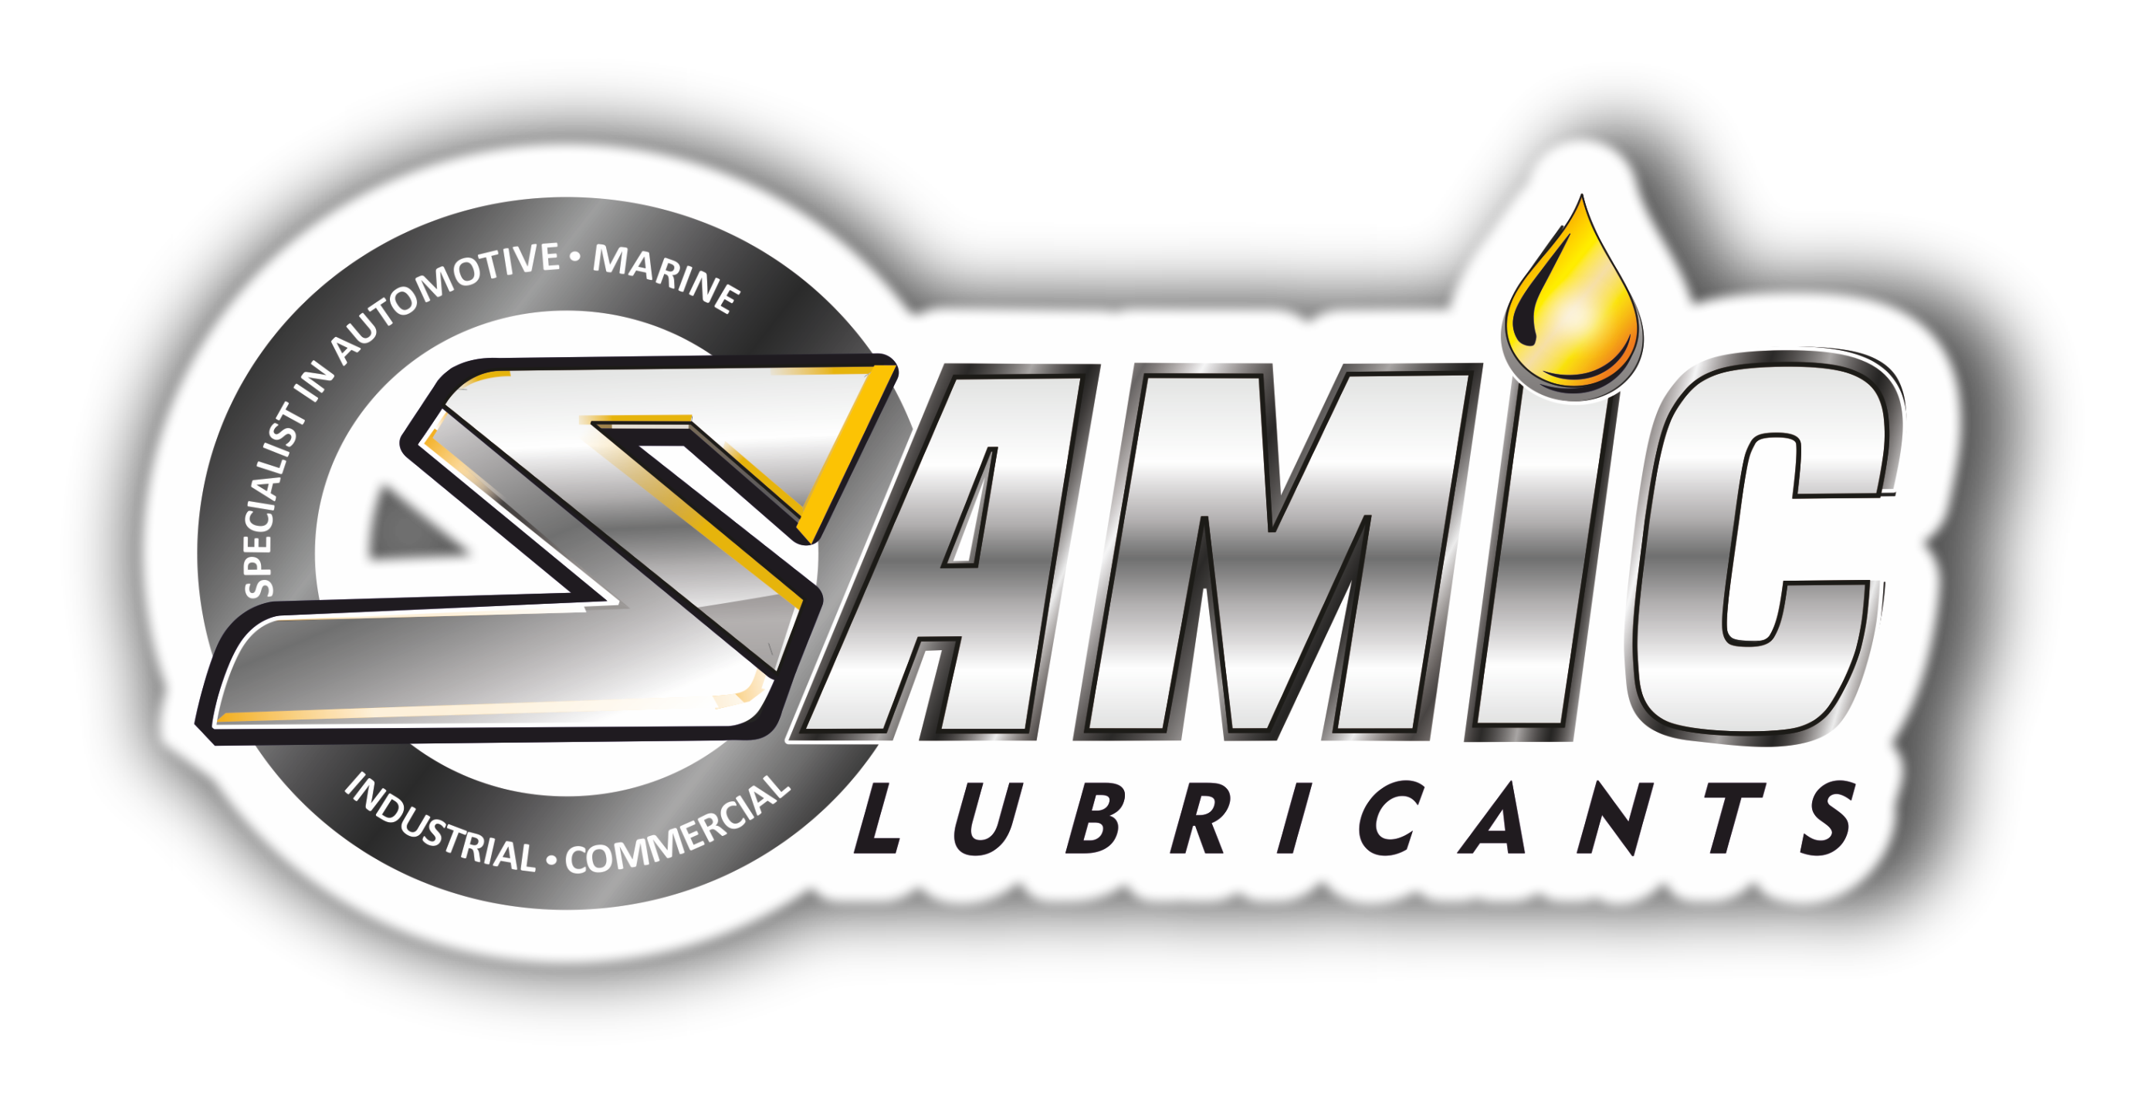
SAMIC ELEKTRA 7000 SG.CD
Multigrade Gasoline/Diesel/CNG/LPG Engine Oil

Product Data Sheet
Product Description
Samic Elektra 7000 SG/CD series are formulated with high quality base stocks and balanced additive system to provide high level of engine protection and performance. It works harder than other conventional motor oils by continuously preventing dirt and sludge build-up and reduces engine noise. This product meets the requirements of most car manufacturers and is suitable for standard services.

Performance & Customer Benefits
- Good engine cleanliness, due to improved detergency and dispersancy.
- Good wear protection and improved resistance to oxidation.
- Superior protection against viscosity and thermal breakdown.
- Superior sludge protection for greater engine reliability.
- Easier cold starting compared to mono-grade engine oils.

Specifications & Recommendations
Samic Elektra 7000 SG/CD meets or exceeds following International and Builder specifications:
- API SG, SF, CD
- ACEA A2/B2

Main Application
Samic Elektra 7000 SG/CD is suitable for use in following:
- Automotive gasoline, diesel, CNG & LPG engines.
- Passenger cars, SUVs, light trucks and vans.
- Pleasure boats, motorcycles without wet clutch, etc.
- Moderate duty CNG/LPG vehicles.
- Naturally aspirated or turbo-charged indirect injection diesel engines.

Typical Physical Characteristics
Samic Elektra 7000 SG/CD | Test Method | Units | 20W-40 | 20W-50
Density @ 15 ⁰C | ASTM D 4052 | gm/cc | 0.888 | 0.890
Viscosity @ 100 ⁰C | ASTM D 445 | cSt | 14.30 | 20.4
Viscosity @ 40 ⁰C | ASTM D 445 | cSt | 107 | 175
Viscosity Index | ASTM D 2270 | - | 137 | 136
Pour Point | ASTM D 97 | °C | -30 | -30
Flash Point (COC) | ASTM D 92 | °C | 230 | 236
Total Base Number | ASTM D 2896 | mg KOH/g | 6.0 | 6.0
Phosphorous | ASTM D 4951 | % wt | 0.070 | 0.070
CCS Viscosity | ASTM D 5293 | cP | 6020 @ -15 °C | 6060 @ -15 °C
The above figures are typical of blends with normal production tolerance and do not constitute a specification.

For further information, please contact: sales@samiclubricants.com

