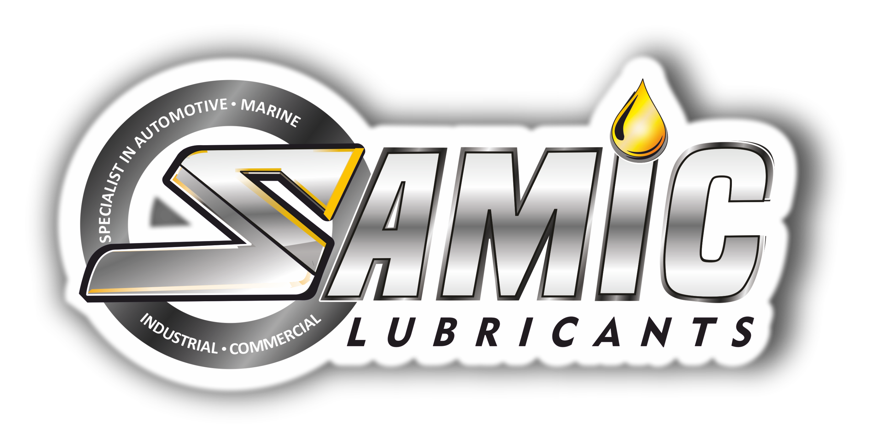

Eiffel Rock Drill oil Series
High Performance Pneumatic Rock Drill & Tool oils

Product Data Sheet
Product Description
Samic Rota RD Series of lubricants are supreme performance Pneumatic Rock Drill & Tool oils, formulated with high quality base stocks fortified with sulfur-phosphorus additive system. They are designed to work efficiently in pneumatically operated rock drills in underground and surface mining operations. They offer optimum adhesiveness and emulsification with water to avoid adverse effects of rust and corrosion. Their excellent wear protection property helps in reducing component wear and maintains adequate lubrication film to carry high loads.

Performance & Customer Benefits
- High thermal & oxidation stability protects against deposit formation and oil thickening, especially in critical areas of air driven tools where elevated temperatures are found.
- Excellent wear protection and outstanding lubrication performance, especially in percussion tools including rock drills operating under severe conditions.
- Excellent corrosion protection even during severe water ingress, for longer component life.
- Compatible with hoses, seals and gaskets, leads to minimum leakage and reduced contamination.
- Excellent demulsifying properties, low foaming and good air release characteristics.

Main Applications
Samic Rota RD Series are suitable for use in Highway construction, Building construction and underground & surface mining operations.
- Oil mist lubrication systems and air tools.
- Gear and bearing lubrication applications where water ingress cannot be avoided.
- Percussion type Pneumatic tools, including those used for rock drills.

Typical Physical Characteristics
Samic Rota RD Series series | Test Method | Units | 68 | 100 | 150 | 220 | 320 | 460
ISO Viscosity Grade | ISO 3448 | - | 68 | 100 | 150 | 220 | 320 | 460
Density @ 15 ⁰C | ASTM D 4052 | gm/cc | 0.880 | 0.887 | 0.894 | 0.898 | 0.900 | 0.905
Viscosity @ 40 ⁰C | ASTM D 445 | cSt | 68.9 | 100.8 | 150.2 | 220.5 | 320.9 | 460.9
Viscosity @ 100 ⁰C | ASTM D 445 | cSt | 8.76 | 11.17 | 14.62 | 18.85 | 24.10 | 30.54
Viscosity Index | ASTM D 2270 | - | 98 | 95 | 95 | 95 | 95 | 95
Pour Point | ASTM D 97 | °C | -27 | -24 | -24 | -21 | -18 | -12
Flash Point (COC) | ASTM D 92 | °C | 218 | 226 | 238 | 248 | 256 | 268
Copper Strip Corrosion | ASTM D 130 | - | 1B | 1B | 1B | 1B | 1B | 1B
Rust Test-Proc B | ASTM D 665 | - | Pass | Pass | Pass | Pass | Pass | Pass
Foam Seq I,II,III | ASTM D 892 | ml/ml | 0/0 | 0/0 | 0/0 | 0/0 | 0/0 | 0/0
The above figures are typical of blends with normal production tolerance and do not constitute a specification.

For further information, please contact: sales@samiclubricants.com

