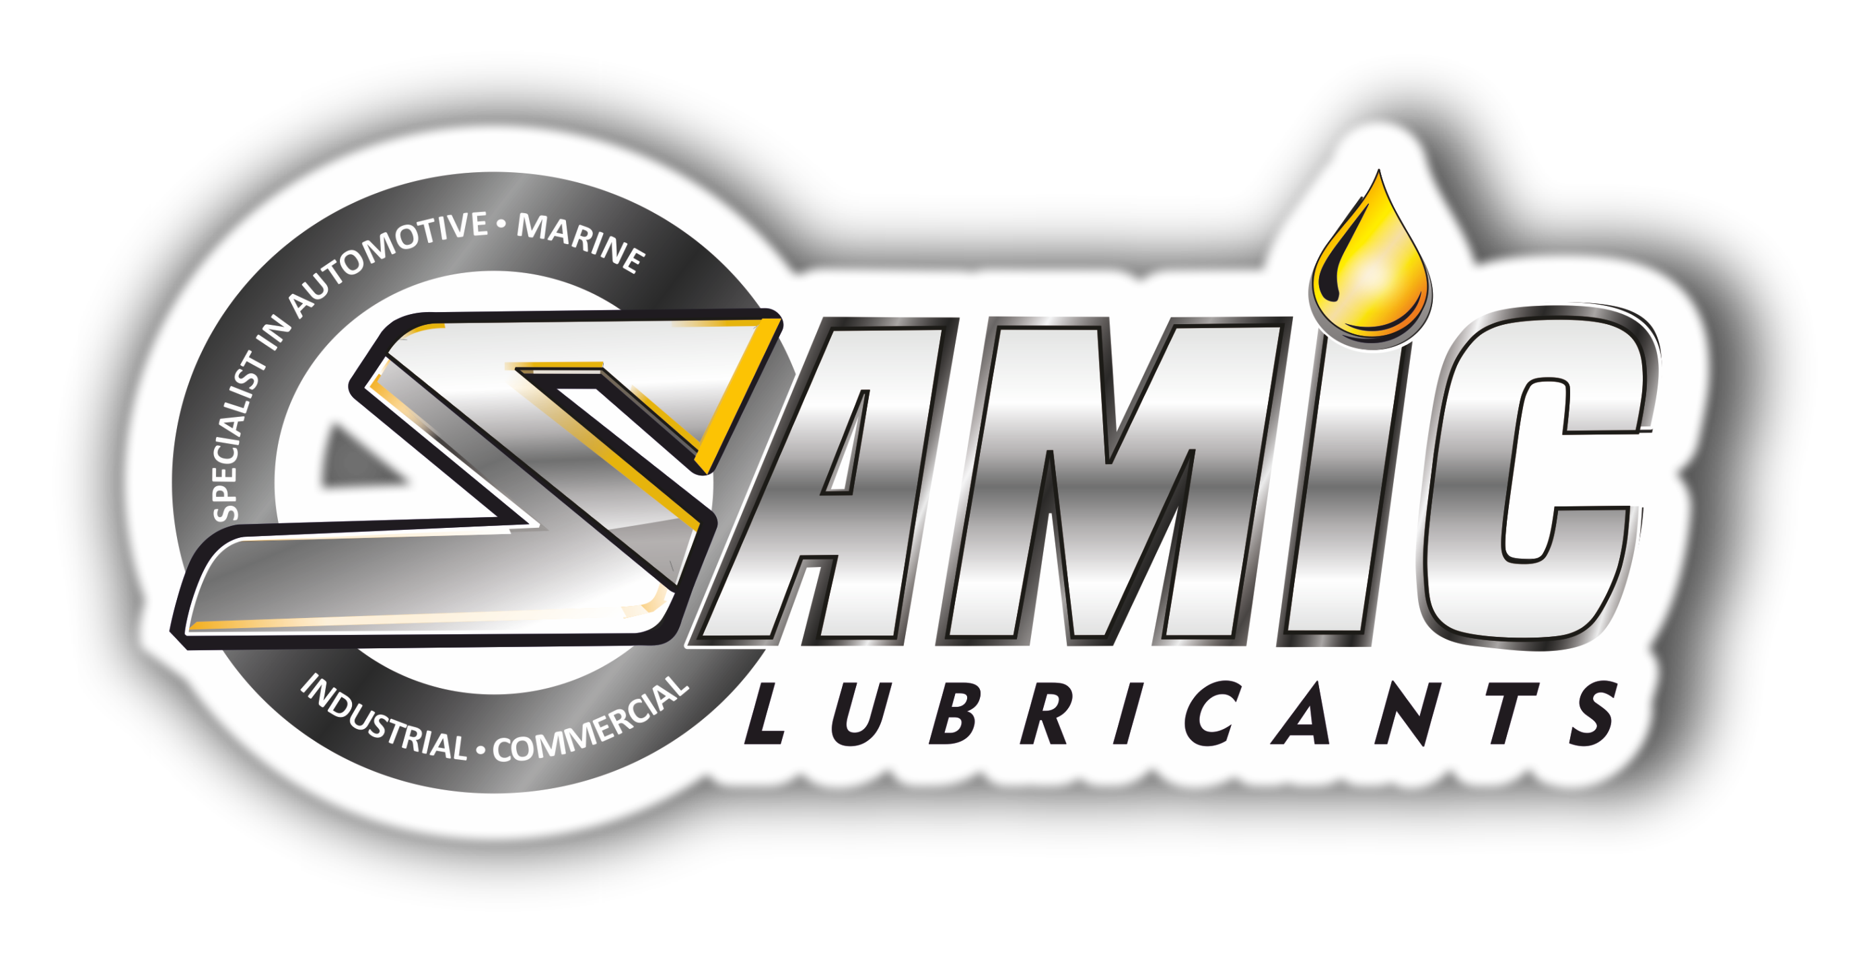

Samic Coast Guard 15 series
High Performance Monograde Marine Diesel Engine Oils

Product Data Sheet
Product Description
Samic Coast Guard 15 series is a range of high performance marine diesel engine oils formulated with premium quality base stocks and selected additives to ensure optimum performance and protection for trunk piston engines, operating on low sulphur distillate fuels. Suitable for heavy duty diesel engines in Marine and Industrial applications, where monograde oils are specified. It provides excellent protection in engines, against high temperature piston deposits, wear, corrosion and foaming under severe operating conditions.

Performance & Customer Benefits
- Excellent oxidation & thermal stability reduces sludge build up and keeps the engine cleaner.
- Outstanding protection against ring and liner wear.
- Excellent resistance to the action of water.
- Excellent filtration and centrifuging capabilities.
- High detergent & dispersant capabilities, ensures cleanliness and long life for engine and transmission systems.
- Excellent TBN reserves & retention, provides improved acid neutralization and protection against corrosive wear.

Specifications & Recommendations
Samic Coast Guard 15 series meets or exceeds following International and Builder specifications:
- API CF

Main Application
- Suitable for lubricating high and medium speed Diesel engines, used for fishing fleets and river transport applications.
- Main and auxiliary engines of all types and ratings, naturally-aspirated, turbocharged or supercharged.
- Clutched reduction driver, reversing gears system, stern tubes and bearings

Typical Physical Characteristics
Samic Coast Guard | Test Method | Units | 1530 | 1540 | 1550
SAE Grade | -- | -- | 30 | 40 | 50
Density @ 15 ⁰C | ASTM D 4052 | gm/cc | 0.892 | 0.900 | 0.904
Viscosity @ 100 ⁰C | ASTM D 445 | cSt | 11.6 | 14.6 | 19.2
Viscosity @ 40 ⁰C | ASTM D 445 | cSt | 103 | 145 | 218
Viscosity Index | ASTM D 2270 | - | 100 | 99 | 99
Pour Point | ASTM D 97 | °C | -9 | -9 | -9
Flash Point (COC) | ASTM D 92 | °C | 245 | 268 | 276
Total Base Number | ASTM D 2896 | mg KOH/g | 15 | 15 | 15
Sulphated Ash | ASTM D 874 | wt% | 2.1 | 2.1 | 2.1
The above figures are typical of blends with normal production tolerance and do not constitute a specification.

For further information, please contact: sales@samiclubricants.com

