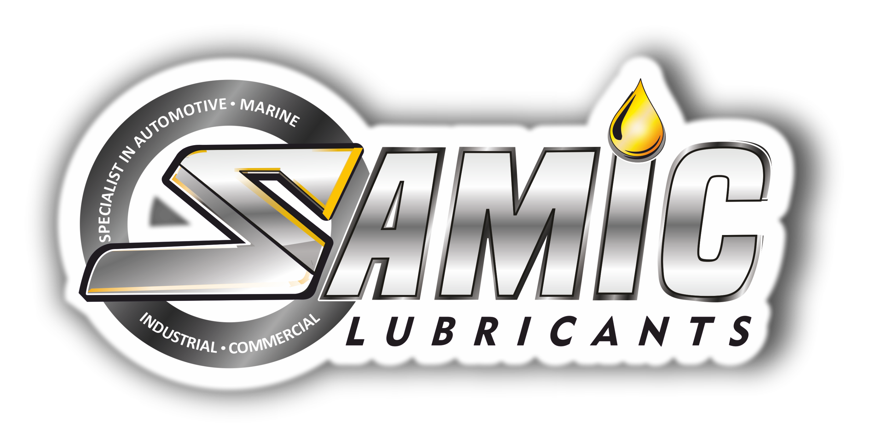

Samic Elect Oil-U Class-I Un-inhibited
High Quality Transformer Oil

Product Data Sheet
Product Description
Samic Elect Oil-U Class-I Un-inhibited Transformer oil is severely refined hydro-cracked / hydro-treated virgin un-inhibited Mineral insulating oils with highest degree of purity and stability. It is manufactured from judiciously selected blend of latest technology feed stocks, which is highly suitable for all grades of Power & distribution Transformers, Circuit Breakers, Oil filled switches and X-ray equipment.

Performance & Customer Benefits
- Low Pour point.
- High dielectric strength.
- Non corrosive as tested by all present methods, DIN & ASTM tests & New IEC 62535 method.
- Low viscosity oils offering excellent and fast heat transfer.
- Compatible with transformer construction material.

Main Application
Σαμιχ Ελεχτ Οιλ−Υ Χλασσ−Ι Υν−ινηιβιτεδ Τρανσφορμερ οιλ ισ ηιγηλψ συιταβλε φορ αλλ γραδεσ οφ
- Power Transformers, Distribution Transformers
- Circuit Breakers, Oil filled switches, X-ray equipment.

Specifications & Recommendations
Samic Elect Oil-U Class-I Un-inhibited Transformer oil meets or exceeds following International and Builder specifications:
- IS 335:2005
- IEC 60296:2003 (superseding IEC 296:1982 Class I)
- BS 148:1998 Class I
- JIS C2320 Class I
Typical Physical Characteristics
Samic Elect Oil-U Class-I Un-inhibited Transformer Oil
No. | Characteristics | Specification | Method | Results
A | FUNCTION
1 | Kinematic Viscosity @ 40°C, mm²/s | 12 (Max) | ISO 3104 | 7.92
 | Kinematic Viscosity @ -30°C, mm²/s | 1800 (Max) | ISO 3104 | 348.2
2 | Pour Point, °C | <= -40 | ISO 3016 | -42
3 | Water Content ppm | < 40 | IEC 60814
 | Bulk Delivery | 30 (Max) | IEC 60814
 | Drum Delivery | 40 (Max) | IEC 60814 | 10.45
4 | Break down voltage, KV(IEC -296) |  | IEC 60156
 | (a) As Delivered (kv) | 30 (Min) | IEC 60156 | 73
 | (b) After Treatment (kv) (IEC-296) | 70 (Min) | IEC 60156
5 | Density @20°C, kg/dm3 | 0.895 (Max) | ISO 3675 | 0.8402
6 | Dielectric dissipation factor (tan Delta)at 90°C | 0.005 (Max) | IEC 60247 | 0.0007
The above figures are typical of blends with normal production tolerance and do not constitute a specification.

B | REFINING / STABILITY
1 | Appearance | Clear Odourless Liquid free from suspended impurities | Visual | Clear Odourless Liquid free from suspended impurities
2 | Neutralization value/ Acidity, mg KOH/g | 0.01 (Max) | IEC:62021-1/ EC:62021-2 | 0.0014
3 | Interfacial Tension, mN/m | 40 (Min) | ISO 6295 | 48
4 | Total Sulphur Content, % Max | No general | IP 373/ISO 14596 | No general
5 | Corrosive Sulphur
 | Corrosive Sulphur, Silver strip@100°C, 18hrs | Non corrosive | DIN 51353 | Non corrosive
 | Cu strip & Kraft paper@150°C, 72hrs | Non corrosive | IEC 62535 | Non corrosive
6 | Anti-oxidant Additives,% | Not detectable | IEC 60666 | Not detectable
7 | 2-Furfural Content, mg/kg | 0.1 (Max) | IEC 61198 | Not detectable
C | PERFORMANCE
1 | Oxidation Stability, 164hrs |  | IEC61125 METHOD - C
 | a)Total Acidity, mg KOH/g | 1.2 (Max) | IEC61125 METHOD - C | 0.0019
 | b)Total sludge, % by mass | 0.8 (Max) | IEC61125 METHOD - C | 0.0026
 | c)Dielectric Dissipation Factor (tan delta)@90°C | 0.5 (Max) | IEC 60247 | 0.0052
D | HEALTH,SAFETY AND ENVIRONMENT(HSE)
1 | Flash Point, °C, PMCC | 135 (Min) | ISO 2719 | 158
2 | Polycyclic Aromatics %mass | 3 (Max) | IP: 346 | 1.02
3 | Total PCB content, mg/kg | Not Detectable | IEC 61619 | Not Detectable
The above figures are typical of blends with normal production tolerance and do not constitute a specification

Packaging Options:
Samic Elect Oil-U Class-I Un-inhibited Transformer oil is offered in 200-210 litres of steel drums and also in bulk in Flexi bags or ISO tanks.

Storage Precautions:
Extreme care is taken while packing these products, including filling of drums in inert atmosphere, as Electrical Insulating oils / Transformer oils are very sensitive to very minute concentrations of contaminants, such as moisture, particulate matter, fibers, etc. Hence, care should be taken to store Samic Elect Oil-U Class-I Un-inhibited Transformer oil in a clean and dry condition. It is strongly recommended that all storage tanks / drums be maintained such that oil is not in contact with atmospheric air. Also these oils should always be stored indoors in climate controlled environments.

For further information, please contact: sales@Samiclubricants.com

