

Samic Elect Oil IH Inhibited Oils
High Quality Transformer Oil

Product Data Sheet
Product Description
Samic Elect Oil IH Inhibited Transformer oils are severely refined hydro-cracked / hydro-treated virgin inhibited insulating oils with highest degree of purity and stability. It is manufactured from judiciously selected blend of latest technology feed stocks, which is highly suitable for all grades of Power & distribution Transformers, Circuit Breakers, Oil filled switches and X-ray equipment.

Performance & Customer Benefits
- Very low sulphur and no DBDS.
- Low Pour point.
- High dielectric strength.
- Non corrosive as tested by all present methods, DIN & ASTM tests & New IEC 62535 method.
- Low viscosity oils offering excellent and fast heat transfer.
- Higher Flash point, resulting on Low evaporation losses and better safety
- Remarkably low sludge and acidity formation, in both ageing and oxidation tests,
results in longer life of oil and equipment
- Compatible with transformer construction material.

Main Application
Samic Elect Oil IH Inhibited Transformer oils are highly suitable for all grades of
- Power Transformers, Distribution Transformers
- Circuit Breakers
- Oil filled switches
- X-ray equipment.

Specifications & Recommendations
Samic Elect Oil IH Inhibited Transformer oils conforms to and exceed the requirements of ASTM D 3487 Type II & IEC 60296:2012 (Table 2: I – High Grade requirements)
Samic Elect Oil IH Inhibited Transformer oils are High Grade Inhibited Transformer oil has superior oxidation stability – meeting the high grade requirements as specified in IEC 60296:2012, high dielectric strength and are used in equipment requiring operations at high elevated temperatures & greater oxidation resistance.

Typical Physical Characteristics
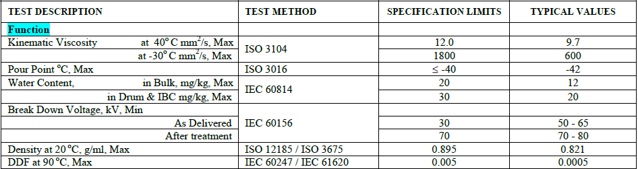
The above figures are typical of blends with normal production tolerance and do not constitute a specification.

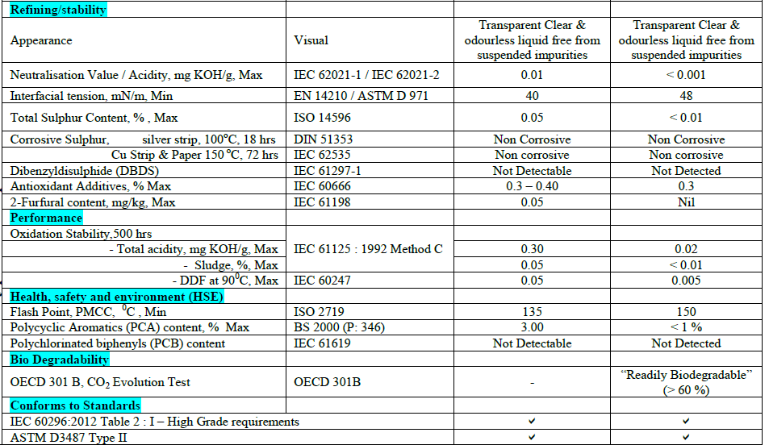
The above figures are typical of blends with normal production tolerance and do not constitute a specification

Packaging Options:
Samic Elect Oil IH Inhibited Transformer oils are offered in 200-210 litres of steel drums and also in bulk in Flexi bags or ISO tanks.

Storage Precautions:
Extreme care is taken while packing these products, including filling of drums in inert atmosphere, as Electrical Insulating oils / Transformer oils are very sensitive to very minute concentrations of contaminants, such as moisture, particulate matter, fibers, etc. Hence, care should be taken to store Samic Elect Oil IH Inhibited Transformer oil in a clean and dry condition. It is strongly recommended that all storage tanks / drums be maintained such that oil is not in contact with atmospheric air. Also these oils should always be stored indoors in climate controlled environments.

For further information, please contact: sales@Samiclubricants.com

