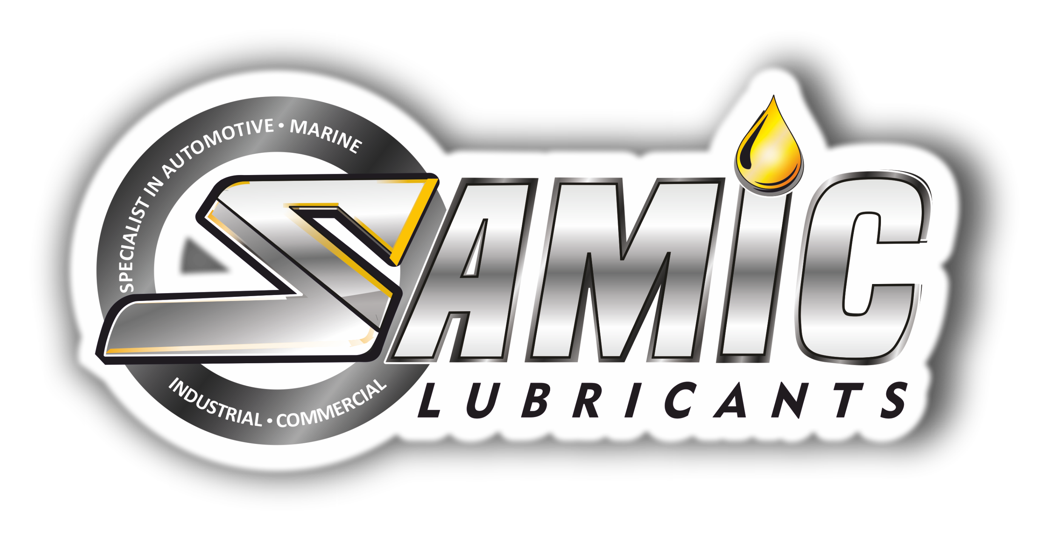

Samic Trans HD series
Heavy Duty Transmission and Drivetrain Oils

Product Data Sheet

Product Description
Samic Trans HD series is a range of extra high performance transmission and drive train oils, formulated with high quality base stocks and advanced additive system to meet or exceed the requirements of Caterpillar TO-4 specification. Suitable to provide heavy duty performance benefits in powershift transmissions, gearboxes, final drives and high pressure hydraulic applications. It helps in maximizing the productivity in construction, quarrying and mining equipment operating under severe conditions.

Performance & Customer Benefits
- Balanced static and dynamic friction coefficients, helps in optimizing clutch friction retention and control of slippage. Thus ensuring increased load carrying capacity & improvement in clutch life.
- Good compatibility with various clutch materials and elastomers.
- Excellent foam control property enhances performance of wet brakes by controlling brake chattering.
- Outstanding oxidation & thermal stability reduces high pressure hydraulic pump wear and minimizes sludge build keeping the application clean.
- Outstanding anti-wear protection & load carrying capabilities, helps in reducing wear and extends the life of gearboxes, final drives and transmissions.

Specifications & Recommendations
Samic Trans HD series meets or exceeds following International and Builder specifications:
- Caterpillar TO-4/TO-4M/TO-2 • Komatsu KES 07.868.1
- Allison C-4 • API GL-4
- Sperry Vickers/Eaton: M-2950-S/I-280-S • Suitable for Wet Brakes

Main Application
- Suitable for use in heavy duty transmissions, gear boxes, final drives and hydraulic systems used in off-highway applications.
- Off-highway applications including: mining, agriculture, construction and quarrying.
- Suitable for certain manual, powershift and automatic transmissions where Allison C-4 fluids (SAE 10W & 30 grades) are recommended.
- Hydraulic applications in most of mobile equipment.

Typical Physical Characteristics
Samic Trans HD | Test Method | Units | 10W | 30 | 50 | 60
Density @ 15 ⁰C | ASTM D 4052 | gm/cc | 0.880 | 0.892 | 0.904 | 0.910
Viscosity @ 100 ⁰C | ASTM D 445 | cSt | 5.6 | 11.6 | 20.5 | 25.6
Viscosity @ 40 ⁰C | ASTM D 445 | cSt | 35 | 108 | 254 | 356
Viscosity Index | ASTM D 2270 | - | 96 | 95 | 95 | 95
Pour Point | ASTM D 97 | °C | -33 | -18 | -12 | -12
Flash Point (COC) | ASTM D 92 | °C | 214 | 230 | 242 | 242
The above figures are typical of blends with normal production tolerance and do not constitute a specification.

For further information, please contact: sales@Samiclubricants.com

