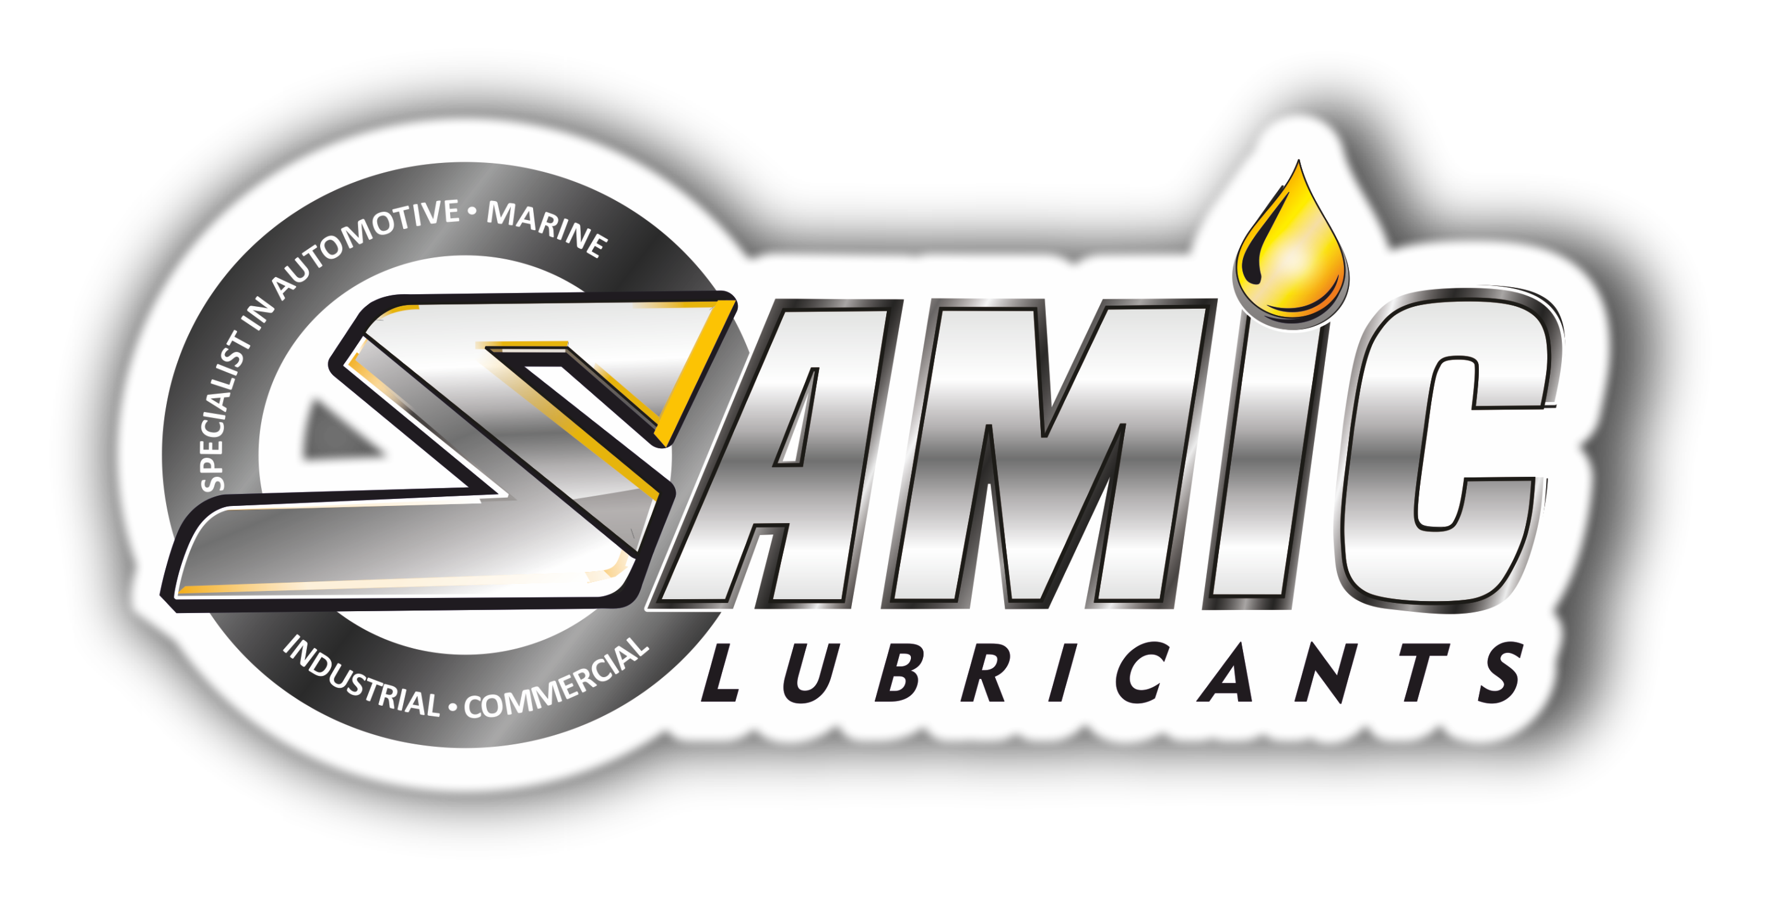

Samic Transfluid UTTO 30, 40, 50
Multipurpose Universal Transmission Tractor Oils

Product Data Sheet

Product Description
Samic Transfluid UTTO series are high performance multipurpose tractor lubricants formulated from high quality base stocks and advanced technology additive system, to meet or exceed transmission and hydraulic fluid requirements. These oils are engineered to deliver the varied lubricant performance properties required in severe duty applications of agricultural and construction equipment drive trains. Moreover, it is particularly well suited for reducing wet brake and Power Take-Off (PTO) chatter.

Performance & Customer Benefits
- Improved thermal & oxidation stability protects against deposit formation and oil thickening, thus maintains the life and performance of lubricant, seal and transmission.
- Strong anti-wear & extreme pressure properties, protects both hydraulic and gear components.
- Excellent resistance towards rust and corrosion protects equipment in wet or humid surroundings.
- Suitability for wide range of equipment simplifies the inventory.
- Improved filterability of oil keeps the system clean and operating smoothly.
Specifications & Recommendations
Samic Transfluid UTTO series meets or exceeds following International and Builder specifications:
- API GL-4, CF-4 • Vickers 35VQ25
- Allison C-4 • Volvo WB-101
- John Deere J20C/J14A/J20D • Caterpillar TO-2
- Denison HF-0, HF-1, HF-2 (T5D & P46 pumps) • JI Case MS 1204-07/09
- ZF TE-ML 03E/05F/06K/17E • New Holland NH 410B
Main Application
Samic Transfluid UTTO series are suitable for use in:
- Heavy-duty transmissions, differentials, final drives, hydraulic systems, power steering systems, wet brakes, PTOs and hydrostatic drives.
- Off-highway industries including agriculture, construction, and quarrying.
- Applications requiring API GL-4 or SAE 80W grade lubricants in gear applications, except hypoid gears.

Typical Physical Characteristics
Samic Transfluid UTTO | Test Method | Units | 30 | 40 | 50
Density @ 15 ⁰C | ASTM D 4052 | gm/cc | 0.892 | 0.900 | 0.904
Viscosity @ 40 ⁰C | ASTM D 445 | cSt | 11.6 | 15.4 | 20.2
Viscosity @ 100 ⁰C | ASTM D 445 | cSt | 102 | 158 | 234
Viscosity Index | ASTM D 2270 | - | 100 | 99 | 99
Pour Point | ASTM D 97 | °C | -24 | -24 | -24
Flash Point (COC) | ASTM D 92 | °C | 230 | 236 | 242
Total Base Number | ASTM D 2896 | mg KOH/g | 6.0 | 6.0 | 6.0
The above figures are typical of blends with normal production tolerance and do not constitute a specification.

For further information, please contact: sales@Samiclubricants.com

